Nithin S
221IT085

IT302 Lab Assignment 4

Q1. A machine puts an average of 5 grams of jelly beans in bags, with a
standard deviation of 0.25 grams. If 45 bags are randomly chosen, write a
R/Python code to find the probability that the mean amount per bag in the
sampled bags is less than 3.5 grams?

Code

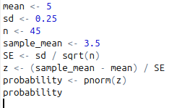

Output
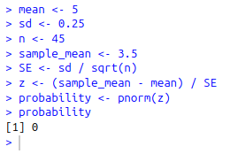

Probability is 0

Q2. A consumer-reports group is testing whether a gasoline additive changes a
car’s gas mileage. A test of seven cars finds an average improvement of 0.5
miles per gallon with a standard deviation of 3.77. Is this difference
significantly greater than 0.7 miles per gallon? Assume the values are
normally distributed. Test at 1% level of significance.

Code
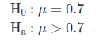

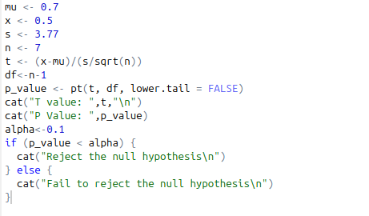

Output

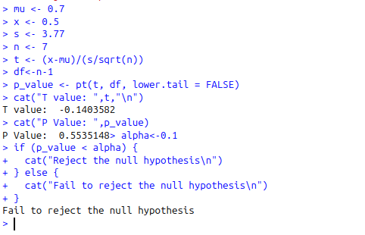

Since the p-value (0.5535) is significantly higher than the significance level of 0.01 (1%), we do not reject the null hypothesis. This indicates that there is insufficient evidence to conclude that the gasoline additive produces a statistically significant improvement in gas mileage greater than 0.7 miles per gallon.

Q3. A car manufacturing company wants to test if its car meets the air pollution
standard that the mean emission is less than 20 ppm of carbon. A random
sample of 10 cars of this company is selected and the cars are tested. The
emission level (ppm) of each of 10 cars as follows
20.5, 15.6, 16.2, 22.5, 17.9, 16.4, 12.7, 19.4, 13.9, 16.6
Is there enough evidence to conclude that the cars meet the air pollution
standard? Test at 1% level of significance.

Code

H0 :μ≥20
H1 :μ<20

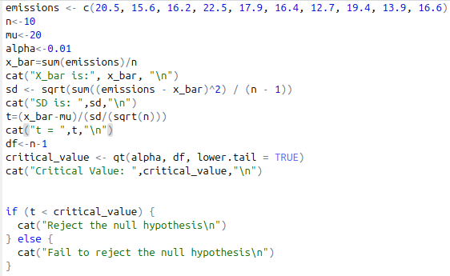

Output

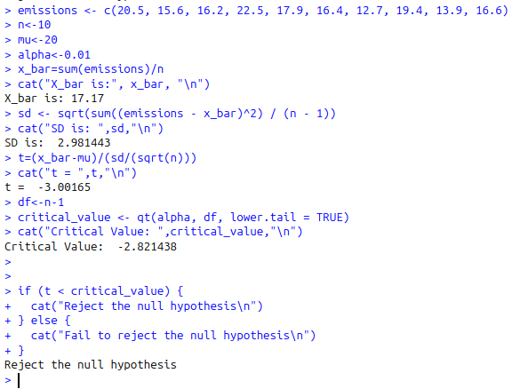

Since the calculated t-statistic (-3.00) is less than the critical t-value (-2.82), we reject the null hypothesis. This conclusion indicates that the data provide sufficient evidence to conclude that the engine's true mean emission level is less than 20 ppm, thereby satisfying the pollution standard at the 1% significance level.

Q4. A machine fills 12-ounce of soda cans. Due to government regulation, the
standard deviation of weights can not exceed 0.03 ounce. A sample of 8
cans is selected and the number of ounces of soda in each can is as given
below. Test at 5% significance level if the machine is functioning properly.
12.3, 12.1, 12.02, 11.98, 12.00, 12.05, 11.97, 11.99

Code

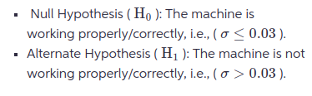

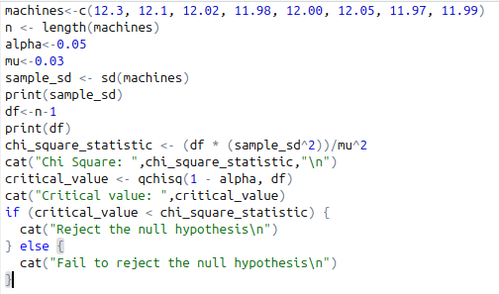
Output

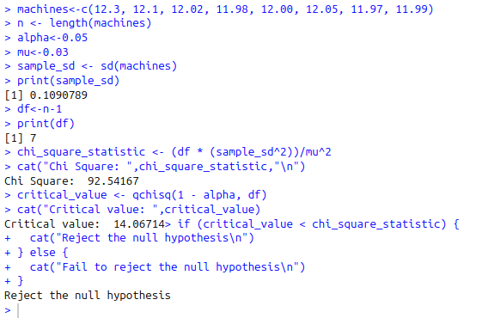

Since our calculated Chi-square value/result (92.63) is more than the critical value (14.067), we reject/dismiss the null hypothesis. This shows that the machine's standard deviation of pop filling excide/surpasses the permitted/controlled limit/restrain of 0.03 ounces, meaning the machine is not working properly/correctly as per Government/administrative standards.

Q5. A college bookstore claims that, on average, a college student will pay Rs.
101.75 per class for textbooks. A student group investigates this claim by
randomly selecting ten courses from the course catalog and finding the
textbook costs for each.
The data collected is 140, 125, 150, 124, 143, 170, 125, 94, 127, 53
Do a test at 5% level of significance of H0: μ=101.75 against the alternative
hypothesis H1: μ>101.75? Assume the values are normally distributed

Code

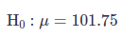

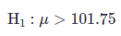

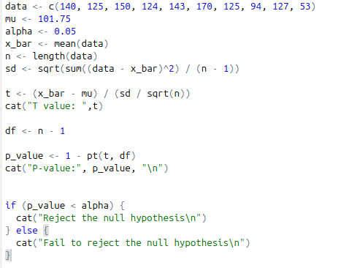

Output

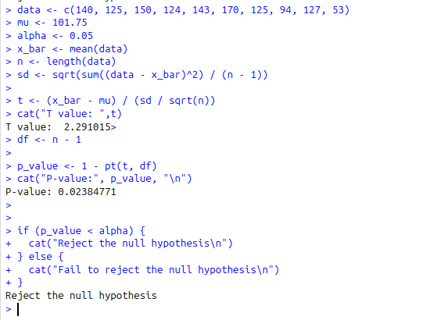

After conducting the hypothesis test, we find that the p-value is less than 0.05 . Thus, we reject the null hypothesis and conclude that there is significant evidence to support the claim that the average textbook cost per course is greater than Rs 101.75

Q6. The data set normtemp (package “UsingR”) contains measurements of 130
healthy, randomly selected individuals. The variable temperature contains
normal body temperature. Perform a test to see if the commonly assumed
value of 98.6 °F is correct. Test at 5% level of significance.

Code

H0: μ = 98.6
H1: μ != 98.6

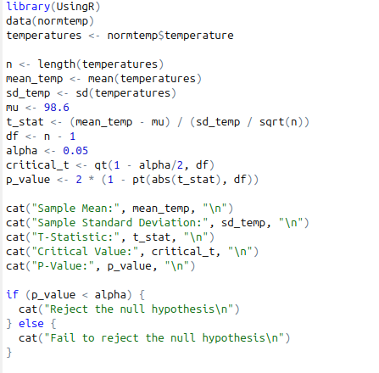

Output

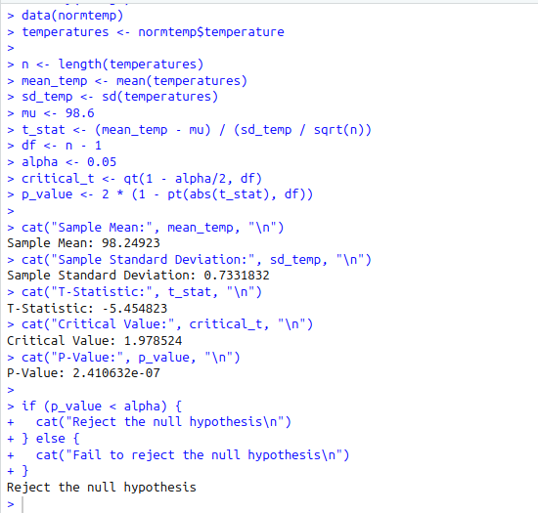

P-value less than alpha.
Reject the null hypothesis. There is sufficient evidence to suggest that the mean body temperature is not 98.6 °F.

Q7. In the babies (package “UsingR”) data set, the variable dht contains the
father’s height. Do a significance test of the null hypothesis that the mean
height is 68 inches against an alternative that it is taller. Remove the values
of 99 from the data, as these indicate missing data. Test at 10% level of
significance.

Code

H0​: μ=68
H1​: μ>68

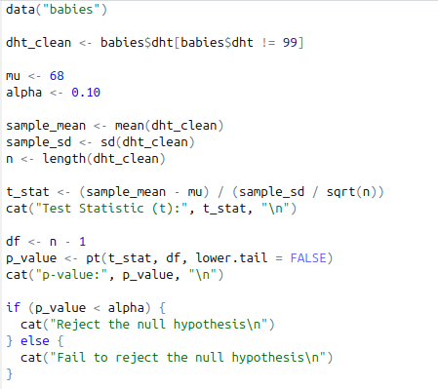

Output

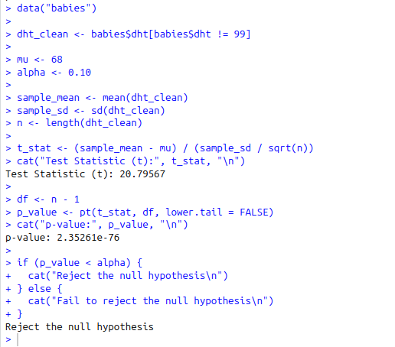

P-value is less than alpha. Reject the null hypothesis. There is evidence that the mean height is greater than 68 inches.

